Ken-Tool announces the 34555 Shark Fin™ Dual Wheel Separation Bag

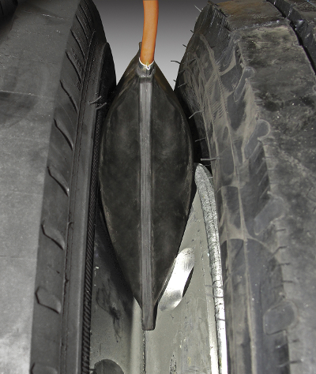
AKRON, Ohio (October 1, 2015) – Ken-Tool has announced the introduction of the Ken-Tool 34555 Shark Fin™ Dual Wheel Separation Bag, engineered to help remove stuck and corroded wheels/tires from truck and trailer axles.

The unique “Shark Fin” bag is an extreme-duty, rubber coated, nearly puncture proof Kevlar bag which uses air pressure to create 5000 pounds of force to separate and remove stuck dual wheels off the axle studs and hubs.

Unlike any other dual wheel separation product on the market, it is safe for use on any wheel type – steel, aluminum or chrome – from 15- to 24.5-in. rim diameters. Stuck wheels are a growing problem due to the corrosion which occurs between wheels (particularly aluminum) and steel studs and hubs.

The Shark Fin bag is inserted vertically between the tires near the 11 and 2 o’clock positions after the tires are off the ground and the lug nuts are loosened. Compressed air is added the bag, using the attached 3 ft. inflation hose. The Shark Fin bag, rated at 150 psi, delivers 2.5 tons of expansion force at 87 psi, breaking the corrosion which prevents removal of the wheels. The Shark Fin bag can also be used, with proper support cribbing, on steering axle wheels and inside dual wheels.

Deflated, the Shark Fin bag dimensions are 9.75” x 8” x 3/8” (25 cm x 20 cm 0.95 cm), and inflated, it expands to 5.5 inches (14 cm) (maximum). The inflation tube features a slotted cap for deflation.
Each Shark Fin Dual Wheel Separation Bag is packaged in a clear poly bag, and weighs 1.3 pounds (0.6 kg). The Ken-Tool Shark Fin Dual Wheel Separation Bag has a MSRP of $499.95 (US).

Ken-Tool products are available through leading tire industry supply distributors worldwide. For more information about these and other professional tire-changing and shop tools, visit www.kentool.com. High and low resolution images of the 34555 Shark Fin Dual Wheel Separation Bag are available on line at http://www.kentool.com/kentoolmedia_images.html. YouTube video of the Shark Fin in action at https://www.youtube.com/watch?v=M1R08Lt8gSU

About Ken-Tool
Ken-Tool is the world’s leading manufacturer of professional tire service hand tools. Headquartered in Akron, Ohio, Ken-Tool has been providing the tire industry and automotive aftermarket with quality products for 95 years.
SEE US AT SEMA SHOW BOOTH #42292, Lower Level, South Hall

Contact:
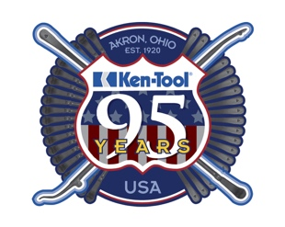
Steve Vyn
Product Line Specialist

Tel: 330-252-1951

Email: svyn@kentool.com

