Ken-Tool’s new 30260 5-piece MorTorq® socket tool set
For new fastener design, delivers high torque to fastener head

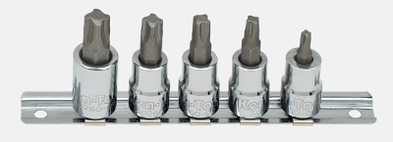AKRON, Ohio (October 28, 2015) – Ken-Tool has announced its latest fastener socket driver set – designed for use on MorTorq® fasteners. This new design is being used by domestic and import auto and truck makers on their newest vehicle models.

The fastener design, often referred to as a “Spiral Drive,” with the driver engaging into the four curved “wings” in the faster head, allows the driver head to have complete contact with the fastener’s recessed drive head. These features allow for uniform torque delivery, combating tool slippage and “rounding out” of the fastener head and the drive tool. The higher surface contact area also makes fastener removal easier, including improved removal of corroded or seized fasteners.
The Ken-Tool 30260 5-piece MorTorq driver set includes a 3/8” driver and M0, M1, M2, M3 and M4 drive heads and a steel storage rail.

The MorTorq driver and drive heads are made from chrome-plated premium grade tool steel alloy, hardened to 60 Rockwell, providing shock resistance and maximum durability. NOTE: The Ken-Tool MorTorq driver set is not designed for use with air drive or impact tools.

The Ken-Tool 30260 5-piece MorTorq socket set is retail-ready, packaged in a secure, hanging blister pack. The Ken-Tool MorTorq socket set carries a Limited Lifetime Warranty.

Ken-Tool products are available through leading tire industry supply distributors worldwide. For more information about these and other professional tire-changing and shop tools, visit www.kentool.com. High and low resolution images of the MorTorq driver set are available on line at http://www.kentool.com/kentoolmedia_images.html.

About Ken-Tool
Ken-Tool is the world’s leading manufacturer of professional tire service hand tools. Headquartered in Akron, Ohio, Ken-Tool has been providing the tire industry and automotive aftermarket with quality products for 95 years.

Contact:
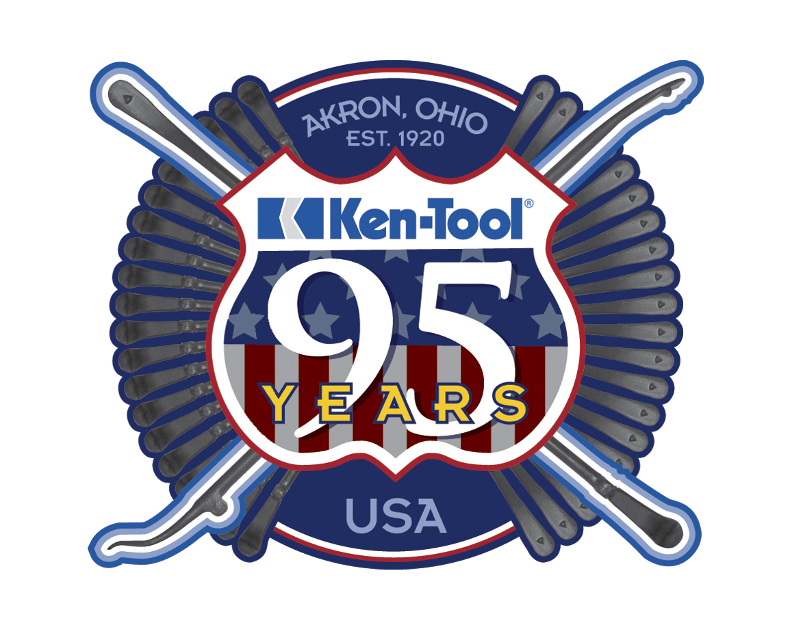Steve Vyn
Interim Sales Manager

Tel: 330-252-1951

Email: svyn@kentool.com

(MorTorq® is a registered trademark of the Phillips Screw Company)

