Ken-Tool announces truck axle nut sockets
Fitments for light, medium and heavy duty trucks

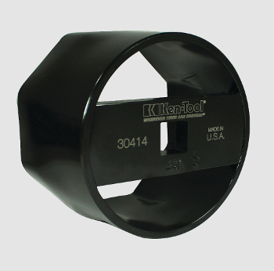
AKRON, Ohio (DATE) – Ken-Tool has announced introduction of a series of sockets designed for removal and installation of axle nuts for the most common truck axle retainer nuts in today’s market.

The line of five popularly-sized axle nut sockets are made in the U.S.A. and cold pressed from high quality, tool-grade steel, assuring a long service life. Each socket is black e-coated to protect it from corrosion. Each socket’s size is stamped on the socket’s driver receiver end, plus the Ken-Tool logo and model number electro-etched on the surface. These sockets are designed for use with breaker bars or ratchet handles, but not or power impact drivers.

These sockets will make an important addition to any service technician’s tool box.

The axle nut sockets are available in the following sizes, plus as a complete set:
30410 – 3.250” – 8 pt Axle Nut Socket, weighs 2.70 lb. (1.2 kg.), MSRP $ 35.75 (US)
30411 – 3.500” – 6 pt Axle Nut Socket, weighs 2.95 lb. (1.3 kg.), MSRP $ 34.99 (US)
30412 – 3.750” – 8 pt Axle Nut Socket, weighs 3.15 lb. (1.4 kg.), MSRP $ 36.99 (US)
30413 – 4.000” – 6 pt Axle Nut Socket, weighs 3.35 lb. (1.5 kg.), MSRP $ 37.99 (US)
30414 – 4.375” – 8 pt Axle Nut Socket, weighs 3.50 lb. (1.6 kg.), MSRP $ 44.95 (US)
30415 – Axle Nut Socket Set – 5 sockets, weighs 16.00 lb. (7.2 kg.), MSRP $ 149.95 (US)

Each socket is polybagged and bar-coded, and features a Limited Lifetime Warranty.

Ken-Tool products are available through leading tire industry supply distributors worldwide. For more information about these and other professional tire-changing and shop tools, visit www.kentool.com. High and low resolution images of the Ken-Tool Truck Axle Nut Socket are available on line at http://www.kentool.com/kentoolmedia_images.html.

About Ken-Tool
Ken-Tool is the world’s leading manufacturer of professional tire service hand tools. Headquartered in Akron, Ohio, Ken-Tool has been providing the tire industry and automotive aftermarket with quality products for 95 years.

Contact:
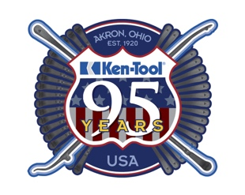
Steve Vyn
Interim Sales Manager

Tel: 330-252-1951

Email: svyn@kentool.com

