Ken-Tool announces 3 drum air brake slack adjusters
For Bendix®, Haldex®, Meritor® brake systems
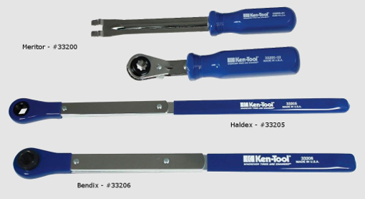
AKRON, Ohio (December 16, 2015) – Ken-Tool has announced three new tools to make the task of adjusting drum air brake linkage to remove dangerous slack on trucks and trailers an easier task, while helping truckers avoid costly fines and penalties.

The tools, made in the U.S.A., fit Bendix®, Haldex® and Meritor® air braking systems. They are ideal for a trucker’s on-the-road tool box, and truck/trailer service centers.

The tools, one for each brake manufacturer’s design, feature the use of durable tool-grade steel, a convenient, offset reversible ratchet design. The tools are available separately.

The two-piece Meritor Automatic Slack Adjuster Set (pn 33200) features a 5/16” double square ratchet and a tool to secure the brake shaft from turning during tightening/loosening of the adjustment nut (with heavy-duty molded resin handles), each tool weighs 10.4 oz. (0.3 kg), is 12 in. (31 cm) long, and priced at $70.95 (US) MSRP for the set. The Haldex Slack Adjuster Tool (pn 33205) uses a 7/16” double offset square ratchet, weighs 10.4 oz. (0.3 kg), is 14.5 in. (37 cm) long, and priced at $33.99 (US) MSRP. The Bendix Slack Adjuster Tool (pn 33206) uses a 9/16” double offset square ratchet, weighs 1.0 lb. (0. 5 kg), is 14.5 in. (37 cm) long, and priced at $51.50 (US) MSRP. The Haldex and Bendix tools each have extra-long handles for improved leverage, with comfortable, slip resistant vinyl hand grips. To reverse direction on the Bendix and Haldex tools, the technician turns the tool over. Each of the part numbers are packaged in polybags with barcoded hang tags for vertical retail display.

The Ken-Tool Air Brake Linkage Adjustment Tools all carry a Limited Lifetime Warranty.

Ken-Tool products are available through leading tire industry supply distributors worldwide. For more information about these and other professional tire-changing and shop tools, visit www.kentool.com. High and low resolution images of the Air Brake Linkage Adjustment Tools are available on line at http://www.kentool.com/kentoolmedia_images.html.

About Ken-Tool
Ken-Tool is the world’s leading manufacturer of professional tire service hand tools. Headquartered in Akron, Ohio, Ken-Tool has been providing the tire industry and automotive aftermarket with quality products for 95 years.

Contact:
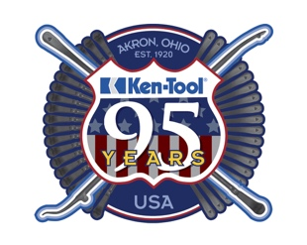
Steve Vyn
Interim Sales Manager

Tel: 330-252-1951

Email: svyn@kentool.com

