Ken-Tool exhibiting at REIFEN 2016 tire industry trade show
Show is largest international tire and rubber industry exposition

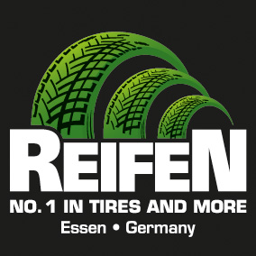
AKRON, Ohio (May 25 2016) – Ken-Tool is again participating in the highly acclaimed REIFEN Tire and Rubber industry trade show, May 24-27, 2016, and held every other year in Essen, Germany. The Ken-Tool booth is in Hall 1, Booth 1A31.

Citing Ken-Tool’s growth in the tire service tool market internationally, Ken-Tool’s President Douglas Romstadt stated, “With our increased presence internationally, we continue to support our new distribution channels by attending the REIFEN show. Over the past several years, the international marketplace, and especially in Europe, has become increasingly important for our line of specialized tools which target the tire service dealers and technicians. We use the show to build the Ken-Tool name and look forward to meeting with our existing customers, plus making new contacts with potential new business partners.”

REIFEN show is held at the huge Essen exposition center in core of Germany’s industrial heartland, the Ruhr region of the Rhine River valley. The international show has over 730 exhibitors, drawn from 44 countries, with buyers from over 130 countries registered for the show. The REIFEN show dates back to 1960, and has established itself as the international meeting place for the tire and rubber industry.

Steve Vyn, Ken-Tool’s Sales Manager notes that the company participated at the tire industry show in Dubai in 2015, which produced positive results. “We find the international market is aware of the Ken-Tool line of premium tire service tools, and has become an increasingly important part of our company’s growth. We have seen excellent growth in the European marketplace, and now have several stocking distributors to serve this vital market.”

Ken-Tool products are available through leading tire industry supply distributors worldwide. For more information about these and other professional tire-changing and shop tools, visit www.kentool.com.

About Ken-Tool
Ken-Tool is the world’s leading manufacturer of professional tire service hand tools. Headquartered in Akron, Ohio, Ken-Tool has been providing the tire industry and automotive aftermarket with quality products for over 95 years.

Contact:
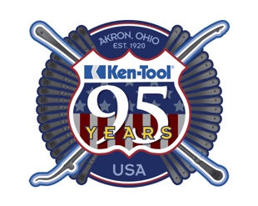
Steve Vyn
Tel: 330-252-1951

Email: svyn@kentool.com

