Ken-Tool names Stephen Vyn to
Director of Sales & Marketing position
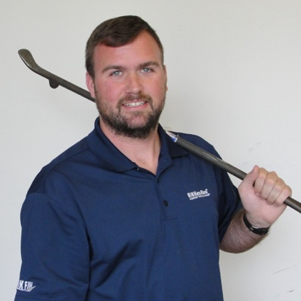
AKRON, Ohio (July 6. 2016) – Ken-Tool has announced the promotion of Stephen (Steve) Vyn to Director of Sales and Marketing. Vyn, a member of the Ken-Tool sales and marketing team for three years, has held the positions of Product Line Specialist and most recently, Interim Sales Manager.

Ken-Tool President, Doug Romstadt, observed that “Steve has proven himself to be a dedicated and focused member of the Ken-Tool management team. In his most recent position as Interim Sales Manager, he has developed a rapport with our customers, sales rep organizations and distributors. He has valuable, hands-on experience with the development of Ken-Tool’s new products over the past three years, which will complement his skill set as Director of Sales and Marketing.”

Vyn commented, “I am focused on continuing the improvements to Ken-Tool’s sales, concentrating first on customer service and satisfaction. Additionally, I will be building upon the foundation of innovative new product expansion that Rock Tyson established. Our Ken-Tool sales and marketing team, which includes Eunice Boyes, Sales and Marketing Coordinator and Leonard Broyles as Customer Service Representative, has been developing a new ‘Take a second look’ initiative (brochure PDF attached) to the tire service industry. It is to remind them of the innovative products Ken-Tool has brought to market to make their workplace more productive and safer...and that there is far more to Ken-Tool than just tire irons and 4-way lug wrenches!” Vyn points to the newly released Shark Fin™ Dual Wheel Separator Bag as a one good example of a product designed to protect the technician’s well-being, while improving workplace productivity.
* * * * * * *
Ken-Tool products are available through leading tire industry supply distributors worldwide. For more information about these and other professional tire-changing and shop tools, visit www.kentool.com.

About Ken-Tool
Ken-Tool is the world’s leading manufacturer of professional tire service hand tools. Headquartered in Akron, Ohio, Ken-Tool has been providing the tire industry and automotive aftermarket with quality products for over 95 years.

Contact:
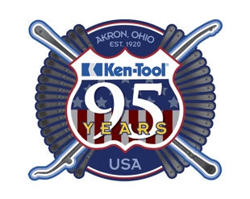
Steve Vyn

Tel: 330-252-1951

Email: svyn@kentool.com

