Ken-Tool introduces the new Model T112 12-bar
Earthmover Inflation Cage
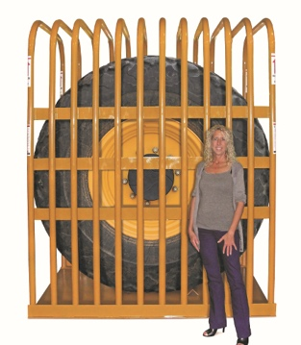
AKRON, Ohio (October 13, 2016) -- Ken-Tool, the leader in tire servicing hand tools and equipment, announces the introduction of its largest tire inflation safety cage – the Model T112 12-bar Earthmover Inflation Cage (pn 36012). This single-piece cage is specifically designed for the inflation of very large earthmoving, mining and agricultural tires. It is the thirteenth safety cage from Ken-Tool.
Utilizing its experience as the industry leader in tire restraining devices, Ken-Tool has developed a cage which dramatically increases the safety to technicians, while protecting equipment and facilities, and allowing inflation of very large tires, up to 87” (221 cm) tall by 48” (122 cm) wide.
T112 12-Bar Earthmover Inflation Cage

The T112 12-Bar Cage is manufactured in the U.S.A. from domestic steel, utilizing precision mandrel bent, very-high strength 12 guage, 2.25” (5.70 cm) diameter structural steel tubes. Using a patented welding process, the ultra-strength tubes are MIG-welded to a 1/4” (0.64 cm) thick steel plate base which features two 1/4” 90° angled steel tire stops, welded in place. Six 4.00” (10.20 cm) by 1/4” thick reinforcing straps are MIG-welded to the tubes for lateral support. All welds are certified to the American Welding Society D 1.1 standards. The cage is rated to 100 psi, and is designed to provide adequate inside clearance to access the rim’s inflation valve. It meets current O.S.H.A. Standard No. 29 CFR Part 1910.177 regulations.

The T112 Earthmover Inflation Cage is 80” long, 60” wide and 99.50” tall (213 cm. X 152 cm X 253 cm), and weighs 1,200 pounds (545 kg), and is shipped by flatbed truck only.

Ken-Tool products are available through leading tire industry supply distributors worldwide. For more information about Ken-Tool’s line of professional tire-changing tools, visit www.kentool.com. High resolution images are of the 12-Bar Cage Earthmover Inflation Cage is available on line at http://www.kentool.com/kentoolmedia_images.html.

About Ken-Tool
Ken-Tool is the world’s leading manufacturer of professional automotive and tire service tools. Headquartered in Akron, Ohio, Ken-Tool has been providing the tire industry and automotive aftermarket with quality products for over 95 years.

Contact:
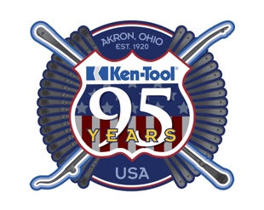
Steve Vyn
Director, Sales & Marketing

Tel: 330-252-1951

Email: svyn@kentool.com

