Ken-Tool announces all-new Stow & Go™
4-way HD lug nut wrench
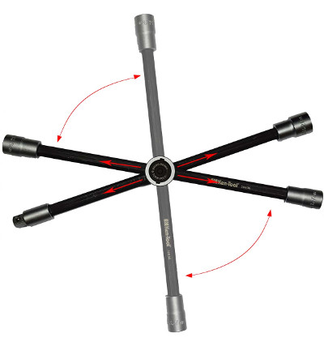
AKRON, Ohio (August 16 2018) – Ken-Tool introduces a very significant improvement to the tried-and-true 4-way lug nut wrench with the new 35636 Stow & Go™ heavy duty wrench.

The Ken-Tool Stow & Go offers user convenience thanks to a fold away design which allows the wrench to be handily stowed in a trunk, a tool box or behind a seat when not in use. For use, the moveable arms easily swing and locks into the 90° position, plus the arms can be slid within the locking hub to create greater leverage when removing and tightening a lug nut.

The Stow & Go features three fixed 17, 19 and 21 mm lug nut sockets, plus a ½” square drive adapter to use other sockets for lug nut removal, plus doubles as a heavy duty, high torque wrench for removal of other bolts or nuts.

To collapse the Stow & Go, simply push the locking button on the hub, and the movable arms fold to the “store” position. The Stow & Go is manufactured from black anodized, high strength tool grade steel alloy, and is 16 inches (40.6 cm) long, 2 inches deep (5 cm); with a folded height of only 17.5 in. (44.5 cm), and weighs 2.9 pounds (1.32 kg).

Ken-Tool products are available through leading tire industry supply distributors worldwide. For more information about this and other professional tire-changing and shop tools, visit www.kentool.com. High and low resolution images of the PN 35636 Stow & Go™ heavy duty wrench are available on line at https://www.kentool.com/index.php/media-center/images .

About Ken-Tool
Ken-Tool is the world’s leading manufacturer of professional tire service hand tools. Headquartered in Akron, Ohio, Ken-Tool has been providing the tire industry and automotive aftermarket with quality products for 98 years.

Contact:
Ben Graham
National Sales Manager
Tel: (330) 535-7177; (330) 317-2793
Email: bgraham@kentool.com

