Now In Stock From Ken-Tool®: MEGA AirBlast™ Bead Seaters

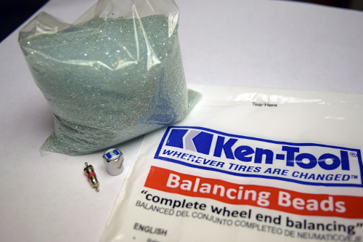
AKRON, Ohio (September 10, 2019) – Ken-Tool® is pleased to announce that new MEGA AirBlast™ Bead Seaters are in stock, and better than ever.

The Ken-Tool® MEGA AirBlast™ Bead Seating Tool uses compressed air to properly seat the bead on Auto, ATV, and Truck Tires. Simply point, release, and watch this fast-acting bead seater do all the work.

The original MEGA AirBlast™ Bead Seater (#31444) has been improved with a digital gauge with backlight capability, and still possesses all features and components as before.

Additionally, we have released a brand new version of the MEGA AirBlast™ Bead Seater (#31445). This innovative and improved model is made from aluminum, making it extremely light and easy to handle, and less than half the weight of the original version. Push-Button Technology has also been adapted into this Bead Seater, allowing for quicker release of air, along with a digital gauge with backlight capability.

Both versions of the MEGA AirBlast™ Bead Seaters are now in stock and ready for immediate shipment from the Ken-Tool warehouse.

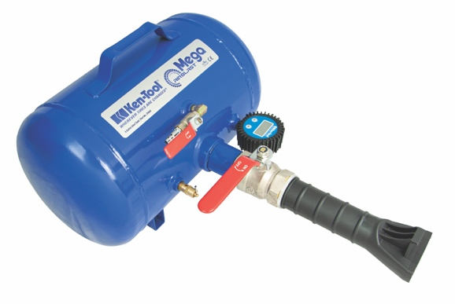

31444
Dimensions (L x W x H) | 251⁄2” x 161⁄2” x 111⁄2” (648 X 419 x 292 mm)
Tank Material | Steel
Maximum Pressure | 120 PSI / 8.25 BAR
Weight | 26 lbs / 12 kg
Discharge Valve | Manual
 | Nitrogen Compatible

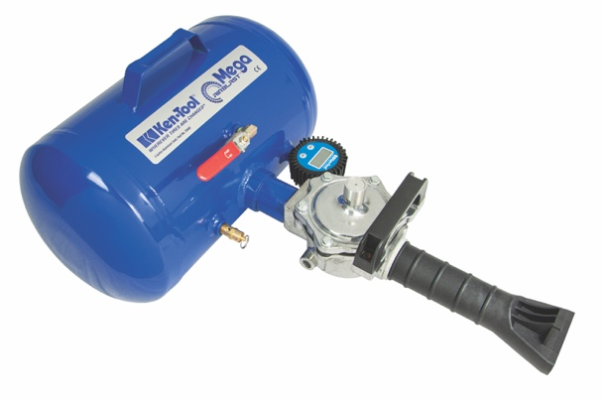

 | 31445
Dimensions (L x W x H) | 251⁄2” x 17” x 111⁄2” (648 X 431 x 292 mm)
Tank Material | Aluminum
Maximum Pressure | 120 PSI / 8.25 BAR
Weight | 11 lbs / 5 kg
Discharge Valve | Automatic
 | Nitrogen Compatible

Ken-Tool products are available through leading tire industry supply distributors worldwide. For more information about this and other professional tire-changing and shop tools, visit www.kentool.com. High and low resolution images of the Ken-Tool Balancing Beads for Trucks are available on line at https://www.kentool.com/category/media-center/images/.

About Ken-Tool
Ken-Tool is the world’s leading manufacturer of professional tire service hand tools. Headquartered in Akron, Ohio, Ken-Tool has been providing the tire industry and automotive aftermarket with quality products for 99 years.
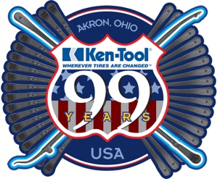

Contact:

Ben Graham
National Sales Manager
Tel: (330) 535-7177; (330) 317-2793

Email: bgraham@kentool.com

