Ken-Tool Announces New Air Boss® Pneumatic Tool Line

AKRON, Ohio (July 16, 2020) – Ken-Tool® is pleased to announce the new Air Boss® Pneumatic Tool Series are officially in stock and available thru Ken Tool’s distribution network.

The Air Boss line of impacts are a lightweight series made of a magnesium alloy which provides enhanced strength and durability over traditional impact wrenches. This exclusive design extends the life of the tool resulting in a lower cost of ownership. The ergonomic design is 20% lighter, reducing fatigue and making the impact more comfortable for all users and applications.

The Air Boss line of tools range in size from the following: Micro Stubby impacts, part number 26402 with a 3/8” drive and the 26403 with a ½” drive. These are the smallest and lightest tools on the market, weighing less than 2.5 lbs., while being capable of providing 400 ft. lbs. of takeoff force.

The Heavy-Duty impact has a 1” extended anvil (part number 26409) and weighs just 22 lbs. and provides 1,850 ft lbs. max torque, useful for larger projects that require additional power and durability.

Seven additional impacts are available as well, including:
- A Mini Stubby (26400, 26401), in 3/8” and ½” drive, with 450 ft lbs. max torque.
- A Traditional pistol style, ½” impacts, two of which are standard duty (26404, 26405) with 780 ft. lbs. max torque, while two are Heavy Duty (26406, 26407), providing 1,250 ft. lbs. max torque. Both the Traditional and Heavy Duty come in either a standard anvil or an extended anvil.
- Along with these tools, Ken tool offers an ¾” drive pistol style impact (26408), providing 1,325 ft. lbs. max Torque.

All these professional tools are ideal for mechanical and tire-service in the Automotive, Trucking, OTR, and Industrial fields, and have an industry leading one-year warranty, which will be serviced by Power Tool Repair, located in Akron, Ohio.

All versions of the Air Boss® tools are now in stock and are available through leading tire industry and tool distributors worldwide.

For more information about this and other professional tire-changing and shop tools, visit www.kentool.com. High and low resolution images of the Air Boss lines are available on line at https://www.kentool.com/images/.

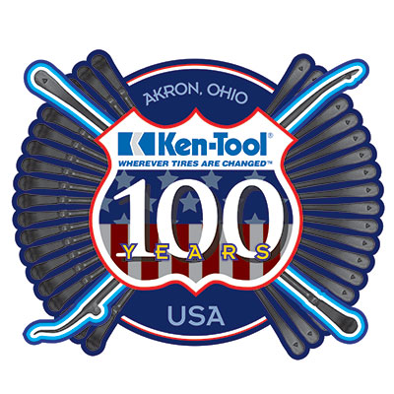
About Ken-Tool
Ken-Tool is the world’s leading manufacturer of professional tire service hand tools. Headquartered in Akron, Ohio, Ken-Tool has been providing the tire industry and automotive aftermarket with quality products for 100 years.

Contact:

Ben Graham
National Sales Manager
Tel: (330) 535-7177; (330) 317-2793

Email: bgraham@kentool.com

